Linux File Management

**1. Creating Files:**

- ‘cd’ : this command will change your current directory to your home directory.

- **Task 1.3:** Create a new directory called "linux_file_management" using the `mkdir` command.

Ex : mkdir linux_file_management

- This command will create a new directory named “linux_file_management” in your home directory.

- **Task 1.4:** Change your working directory to "linux_file_management" using the `cd` command.

Ex : cd linux_file_management

- this command will change your current directory to the “linux_file_management” directory.

- **Task 1.5:** Inside this directory, create three text files: "file1.txt," "file2.txt," and "file3.txt" using the `touch` command.

Ex : touch file1.txt file2.txt file3.txt

- this command will create three empty text files in the “linux_file_management” directory.
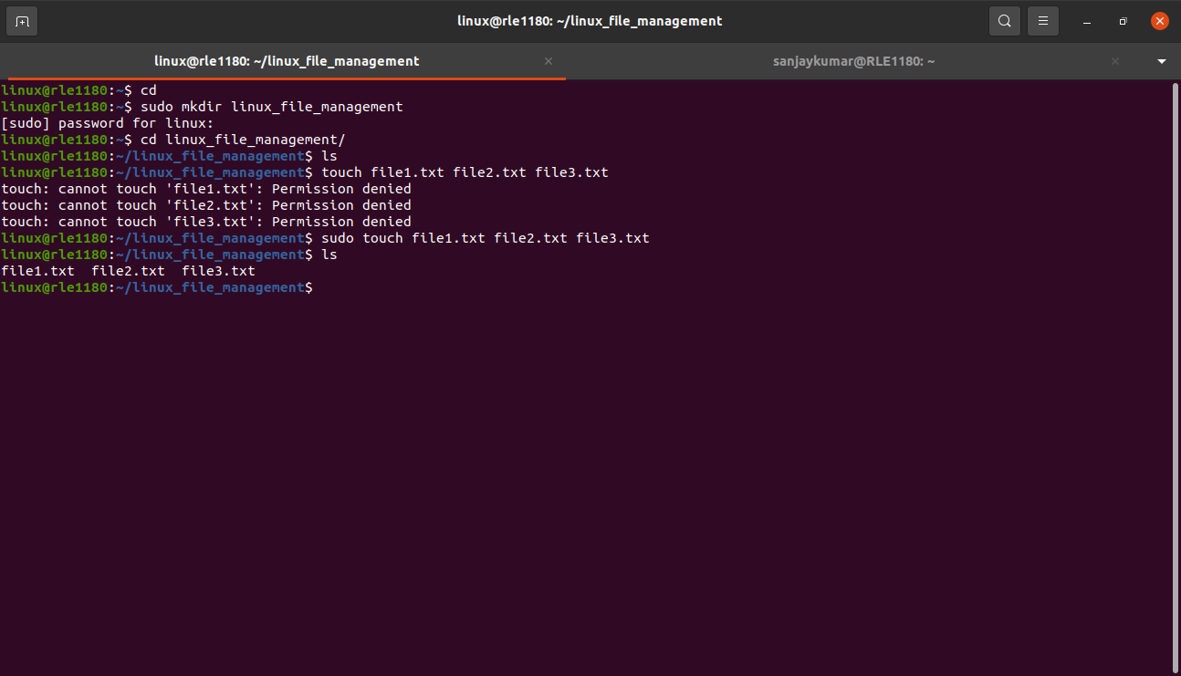

**2. Editing Files:**

- **Task 2.1:** Use a text editor of your choice (e.g., nano, vim, or gedit) to open "file1.txt."

Ex : nano file1.txt

- this command will open “file1.txt” in the nano text editor

- **Task 2.2:** Write a short message (e.g., "Hello, Linux!") in "file1.txt."

Ex : “Hello,Linux!”

- **Task 2.3:** Save your changes and exit the text editor.

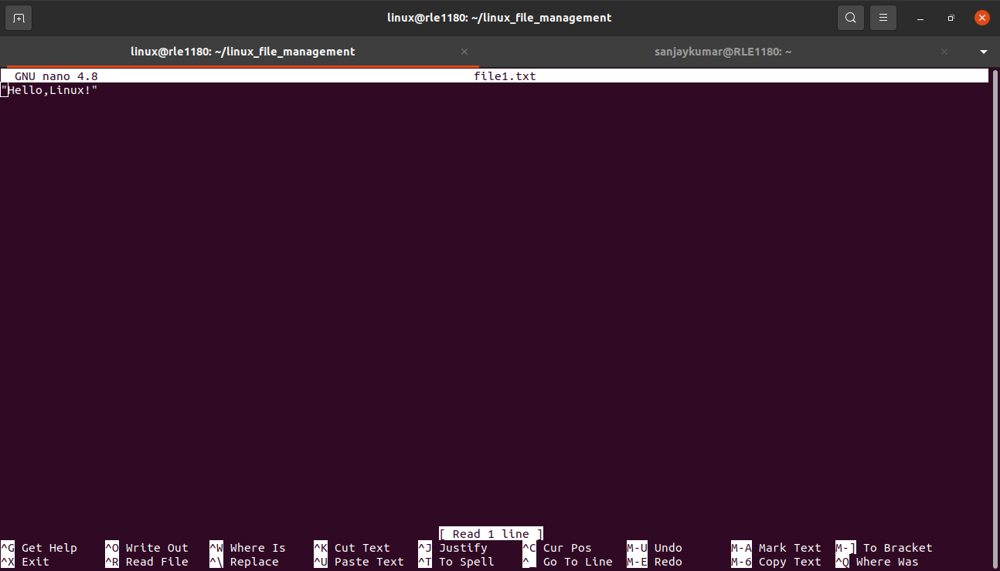

- **Task 2.4:** Use the `cat` command to display the contents of "file1.txt" in the terminal.

- Ex : cat file1.txt

This command will print the contents in “file1.txt” in your terminal.

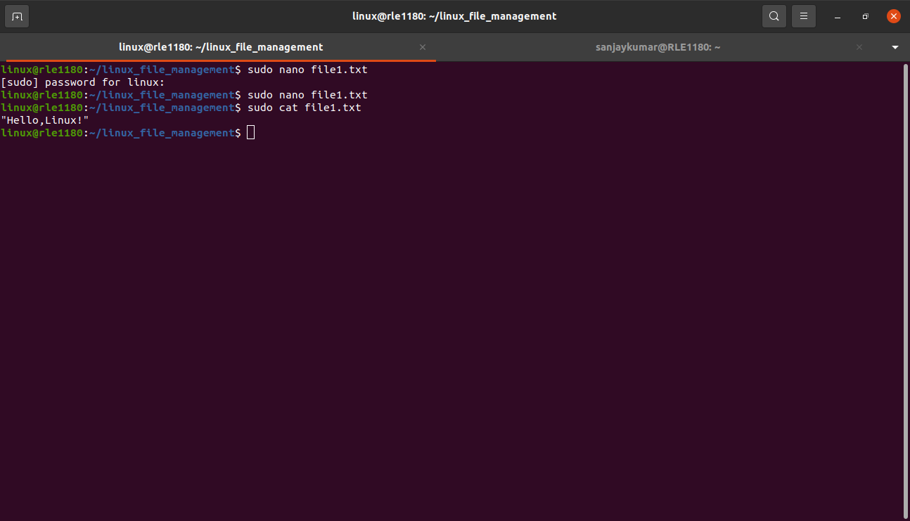
**3. Renaming and Copying Files:**

- **Task 3.1:** Rename "file2.txt" to "newfile.txt" using the `mv` command.

- Ex : mv file2.txt newfile.txt

This command will rename “file2.txt” to “newfile.txt”.

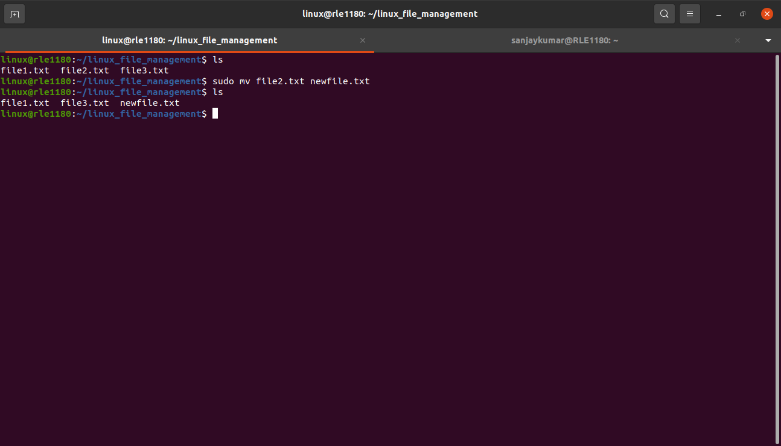

- **Task 3.2:** Create a copy of "newfile.txt" called "file4.txt" using the `cp` command.

Ex : cp newfile.txt file4.txt

This command will create a copy of "newfile.txt" with the name "file4.txt."
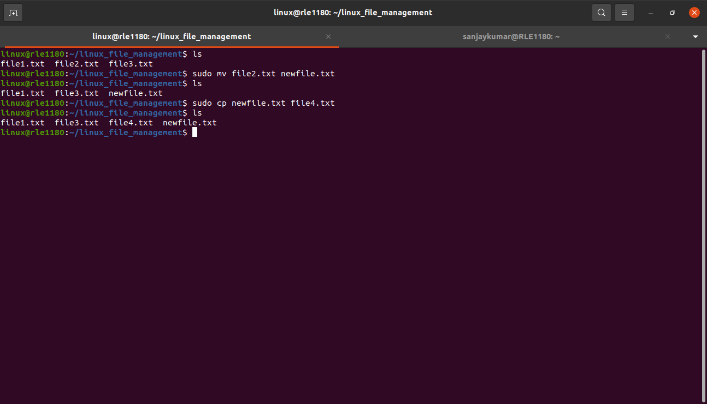

**4. Deleting Files:**

- **Task 4.1:** Delete "file3.txt" using the `rm` command.

Ex : rm file3.txt

This command will delete “file3.txt” file.

- **Task 4.2:** Confirm that "file3.txt" has been deleted.
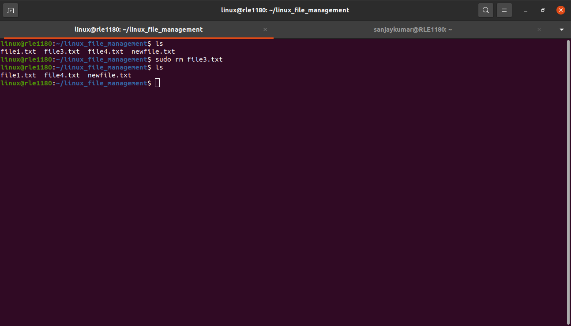
- **Task 4.3:** Delete the entire "linux_file_management" directory and its contents using the `rm` command with the `-r` option (be cautious with this command).

Ex : rm -r linux_file_management

This command will delete the "linux_file_management" directory and all its contents.
